**Parallel testing on Android device using testing**

1. Create two different classes with two different @Test annotations.
2. Setup Appium grid with singlr hub and multipc pcs where each pc has multiple real devices we call node. Different computer different host and port.
3. In the @BeforeClass annotation we will set our DesiredCapabilities class for configuration purpose. We are using TestNG parameter where we are taking 5 parameters from the TestNG.xml file. We will run from testing.xml file. We have to setup our configuration for each devices in testing.xml.
4. You have to start two server instances for two devices and set two port number like 4723,2733. Set the log file path and also allow session override checkbox. Then start the server.
5. Run the test suite from testing.xml.
6. See the log file in your testout folder.

**Step-1**

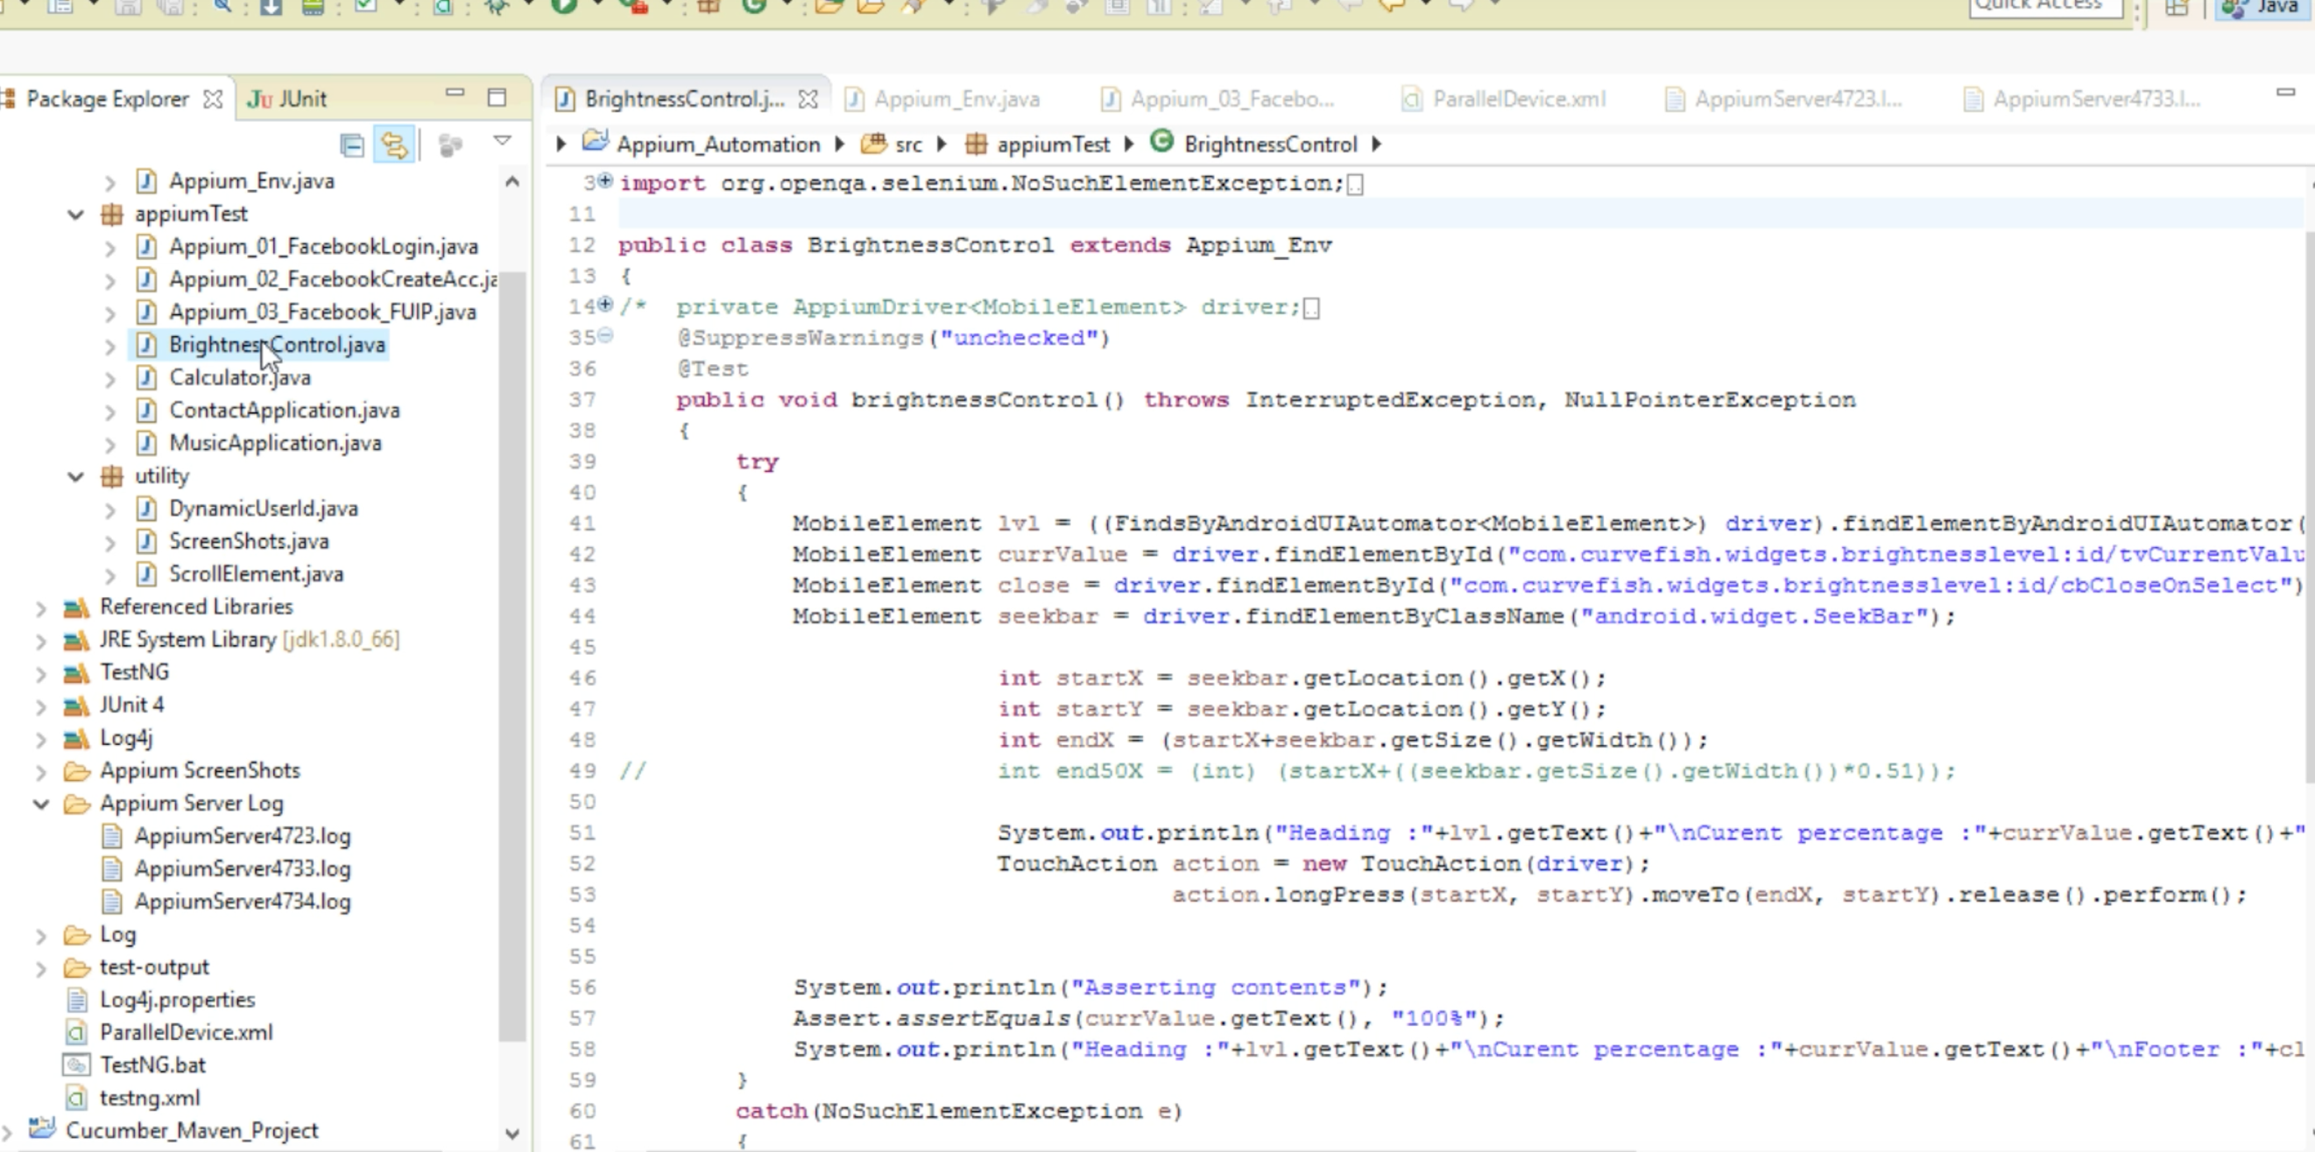

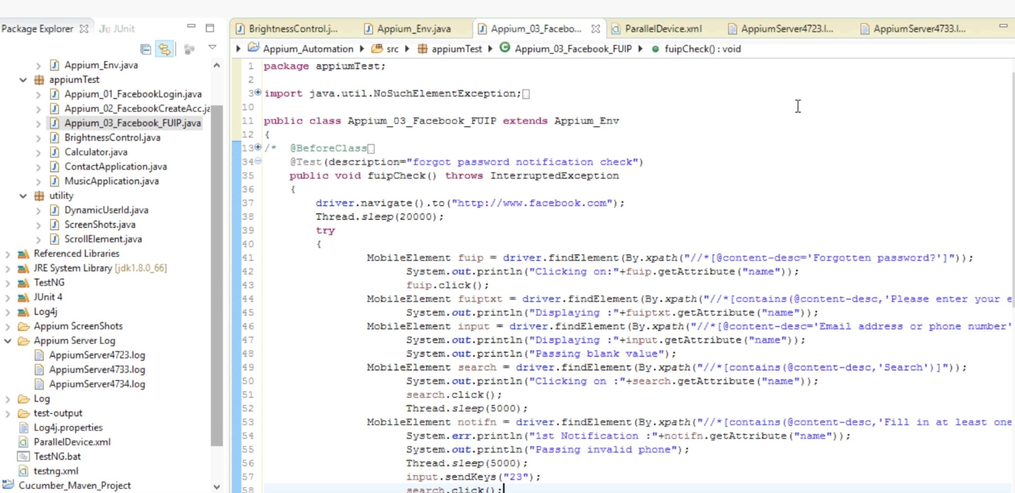

**Step-2**

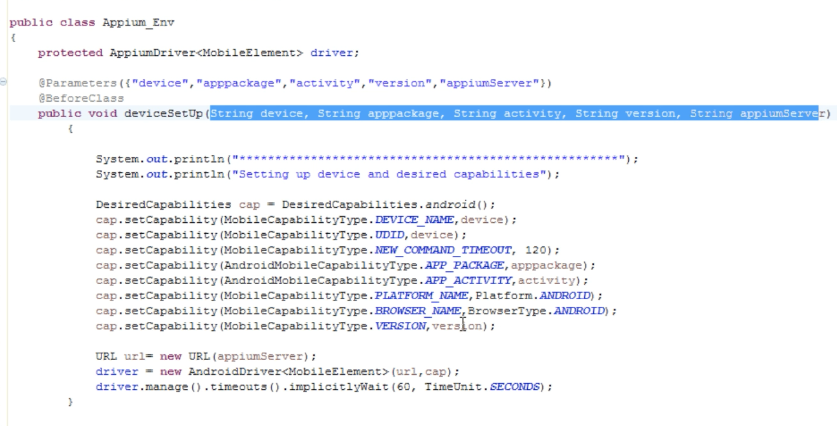

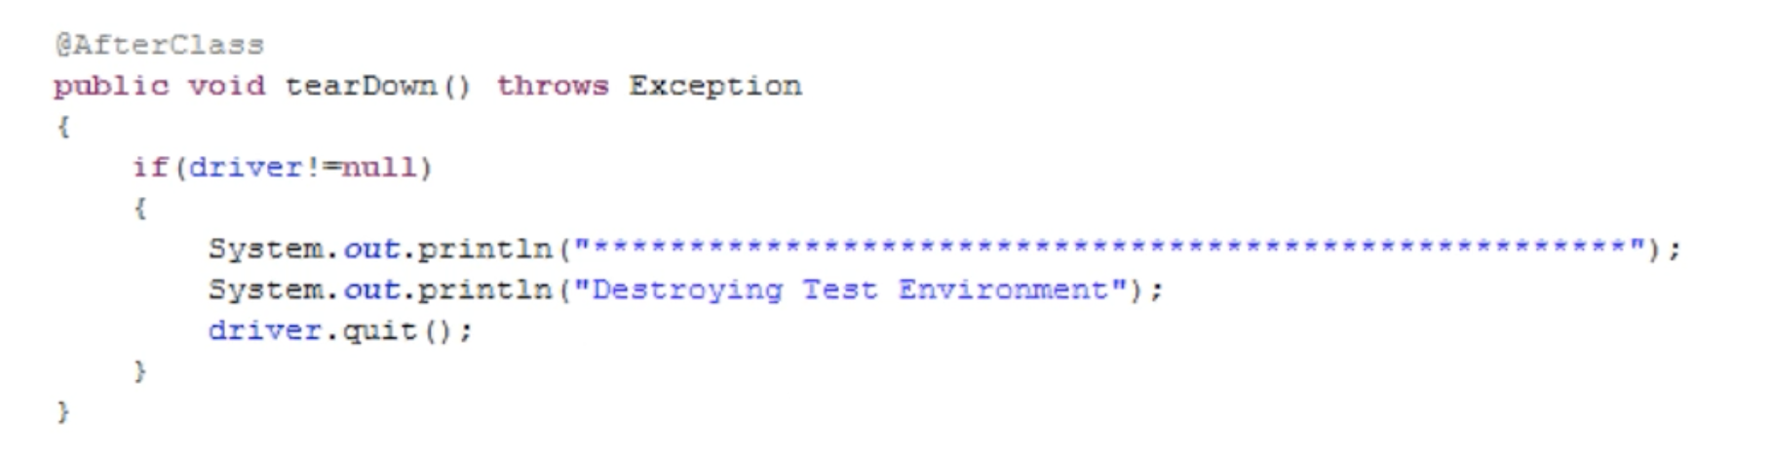

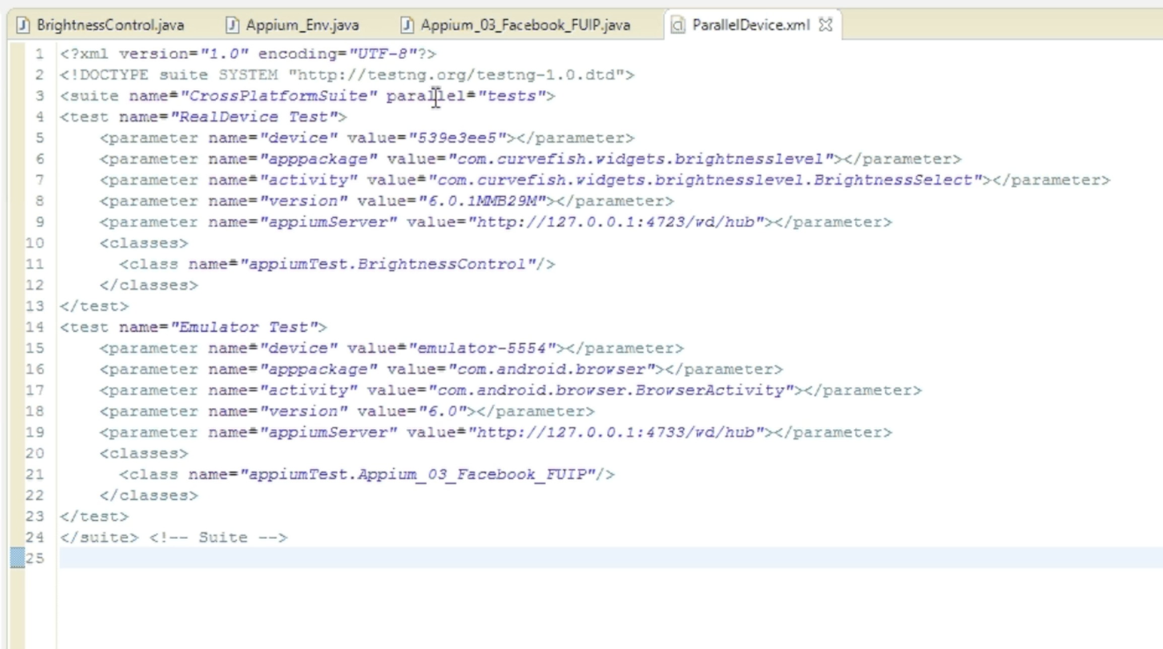

**Step-3**

